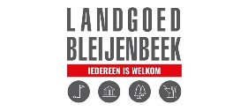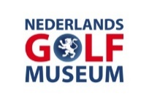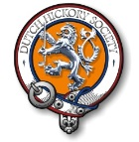

Dutch Golf Museum Open Hickory Tournament 26 April 2025
Please send completed form to dutchhickorytour@gmail.com
Deadline 23 April 2025, 18:00 hr

Male □ Female □
Name:
Member Golfclub Bleijenbeek: yes/no
Member Dutch Hickory Society: yes/no
Members Dutch Hickory Society will enjoy a reduction of € 5,00 per arrangement
E-mail:

Mobile phone number:
Pro □ Amateur □ WHS-handicap:
Rental Hickory golf set € 30 yes/no
Rental Hickory clothing (gents) € 25 via info@hickoryclubs.eu yes/no
Diet wishes:
Any comments:

Friday 25 April:
Golf Course Bleijenbeek practice round yes/no
Prices non-GC Bleijenbeek members:
CC-18h € 62,35
CC-9h € 37,70
Combi € 53,00
Par3/4-18h € 34,85
Par3/4-9h € 24,95 Choice: ……….
Golf Course Bleijenbeek 4-gangen opening dinner €48,30 yes/no

Saturday 26 April
Hickory Golf Arrangement € 109,75 */**/*** yes/no
* Including: welcome coffee/tea and Danish pastry, visit Golf Museum, greenfee,
‘bitterballs’ etc per flight, price ceremony, dinner buffet ***
** Costs Pro’s, members GC Bleijenbeek € 52,90 ***
*** Members Dutch Hickory Society will enjoy a reduction of € 5,00

Optional: packed lunch €13,10 yes/no

